Game Engines

Task 1

Part 1 – A basic Description of the game

Our game is going to be a 2D game based off of Stack 2D, The Tower (stack game) and Tetris, used for inspiration purposes. The game is a hyper casual game with only few mechanics necessary to achieve the main objective of the game, which is to stack and get a highscore.

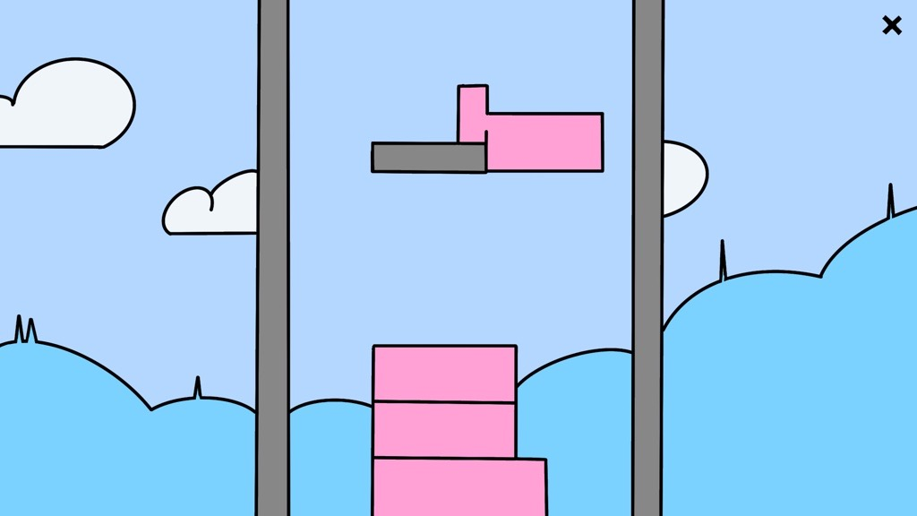

The game would look something like this, having obstacles in the way of the object to conflict with the player while trying to achieve the perfect stack. This will happen after some blocks has been places so that the played gets used to the game before trying to dodge any obstacles.

To have a brief idea, the games core mechanics will be, the player moving left and right with arrow keys or ‘A’ and ‘D’ and be able to press space bar to place the block, whether in the air or on the block, the game will know when and where you place as it will check for block placement.

Gantt Chart

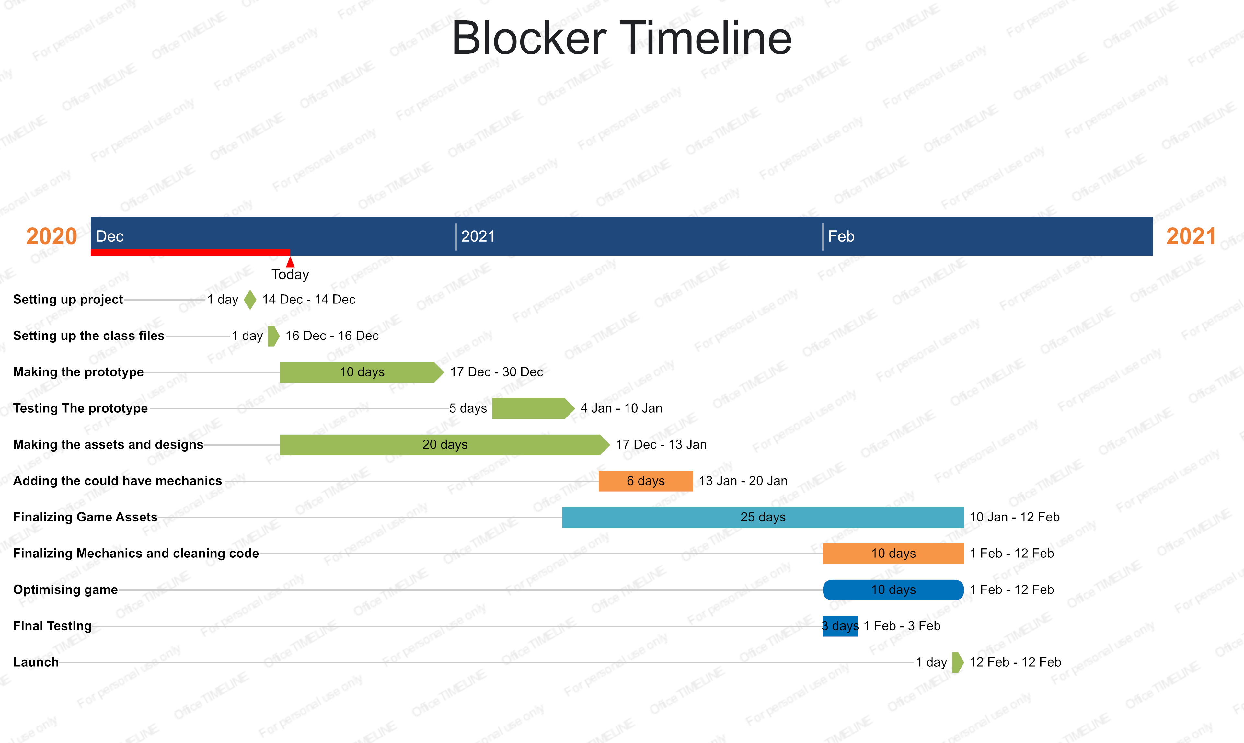

Basically this is an idea of the scope of the project to split the work according to the deadlines, of course this is the process of which we are going to work in, from setting up the project to prototyping to optimizing the game, finally testing and launching to summarize it. This scope will likely change when things are more in place. Currently the project is setup, the class files and game objects are setup, code is partially ready towards the prototype.

CRC Cards

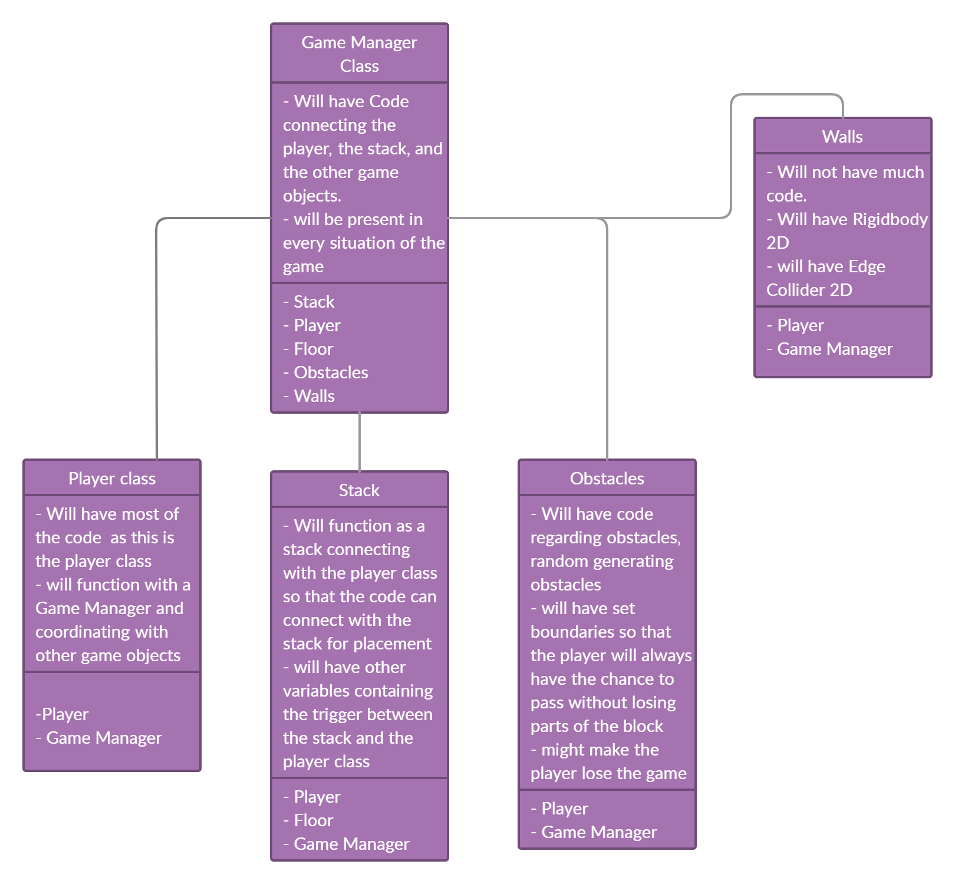

This is how the code will be connected as an idea, of course as we go along things change and might need to be added and changed according to the situation. But this is a general idea. The Game Manager will have the main role in connecting scripts and game objects because of its presence being that it will always be in the game.